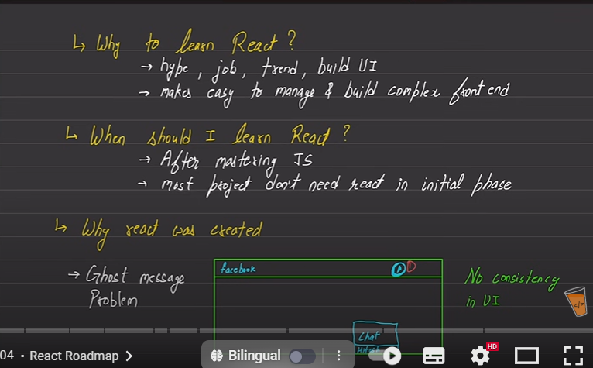

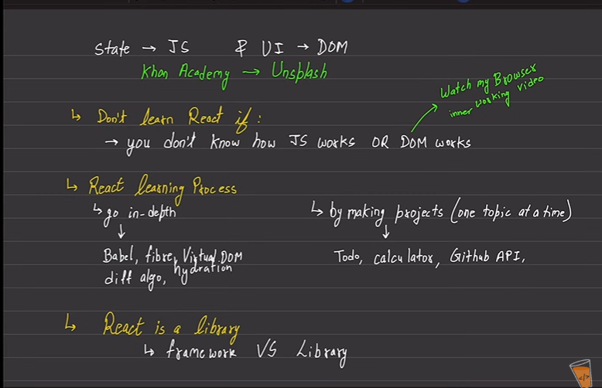

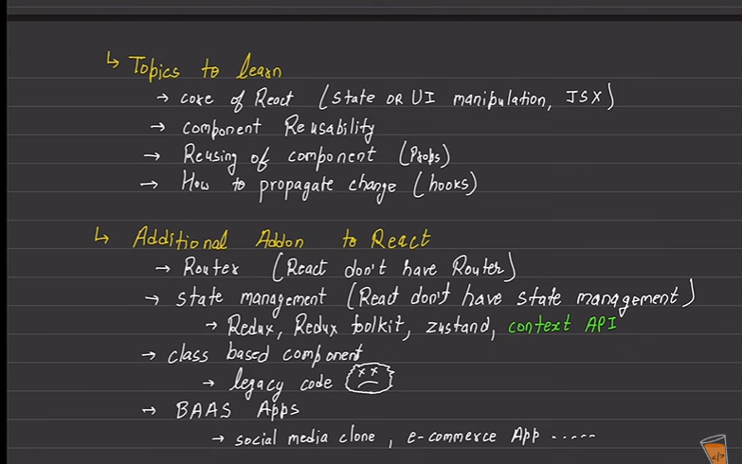

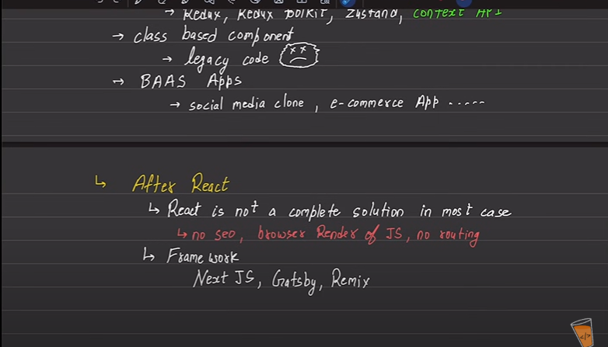

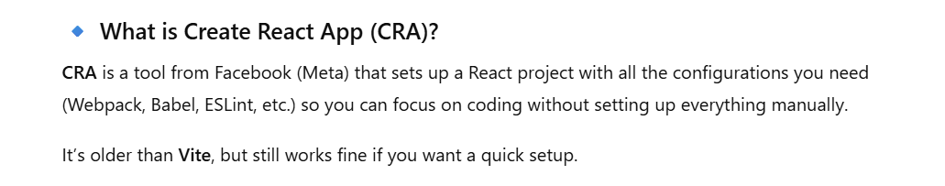

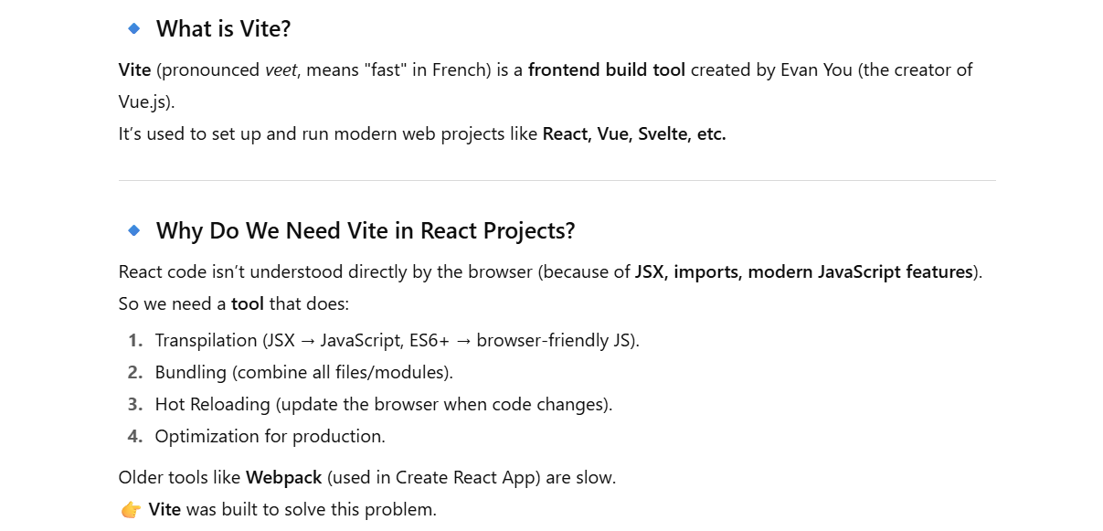

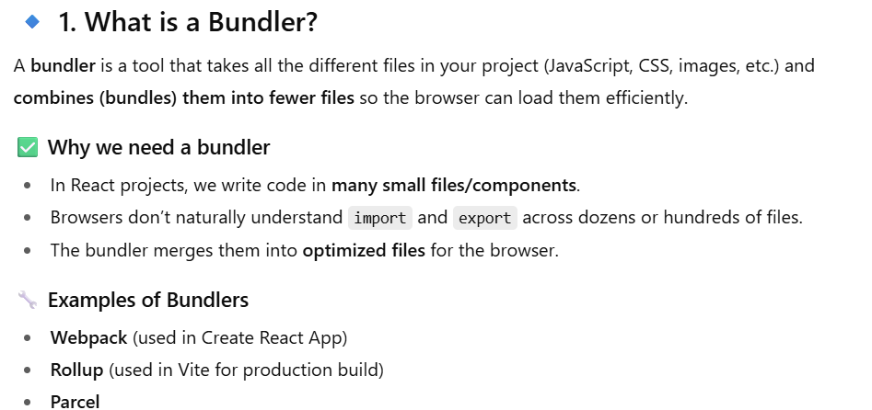

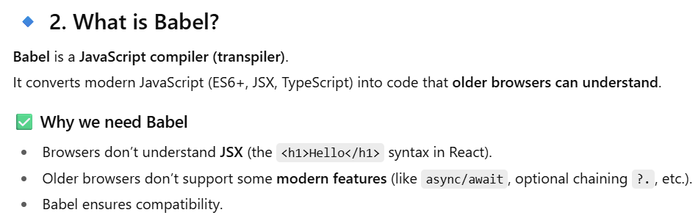

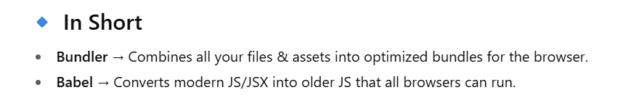

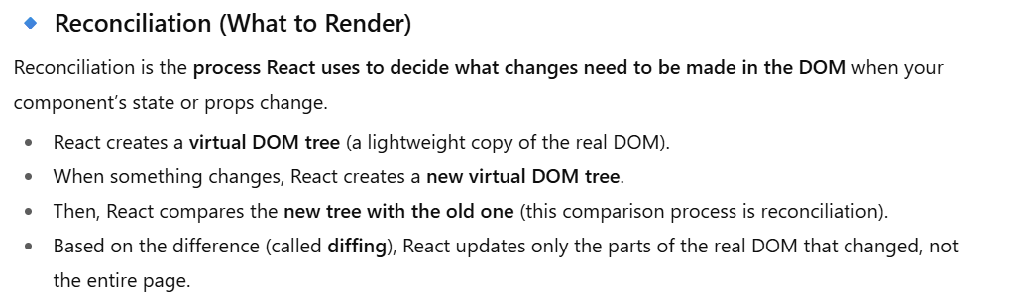

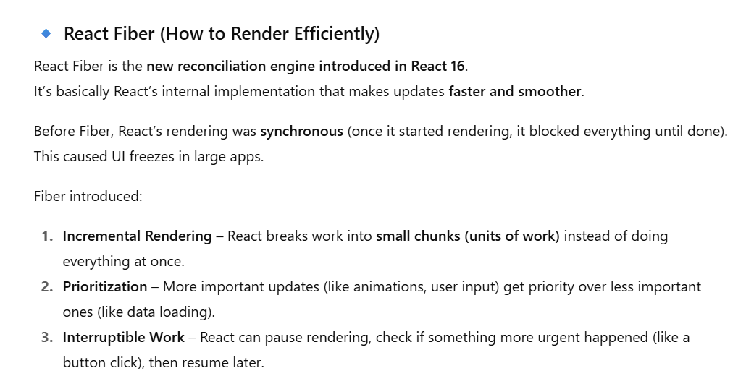

**ID:**

* Key and ID both are different in react. We use specific hook for ID which is useId.

**Key and Loop:**  
 if we use loop in react then must use key due to performance concern.

**Custom Hook:**

* If the custom hook return a component then its extension will be a jsx.
* If the custom hook return a js then its extension will be a js.
* In custom hook we can use built-in hooks

